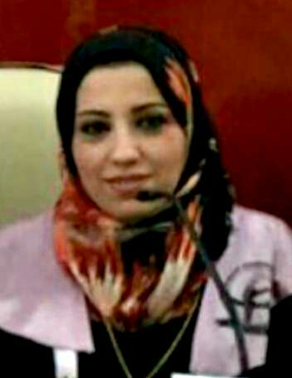

Curriculum Vitae

First Name: Zina Abdul Salam Abdul Razzaq Al - Azzawi
Date of birth: Baghdad / 1976
Marital status: Married
No. of children: (2)
Religion: Muslim
Specialization: Philosophy of Physical Education / Specialization: Biomechanics - Technical Gymnastics
Occupation: Teacher at the Faculty of Physical Education for Girls
Degree: Assistant Professor
Work Address: College of Physical Education and Sports Science for Girls / University of Baghdad
Work Phone 07704310545
Mobile: 07902252844
Email: dr.zina_iraq2012@hotmail.com
First: Educational Qualifications

Bachelor's Degree
University of Baghdad
Faculty Faculty of Physical Education
Date 1998-1999
University of Baghdad
Faculty of Physical Education
Ph.D. University of Baghdad
29/9/2013
8/10/2008
Assistant Professor University of Baghdad - College of Physical Education

