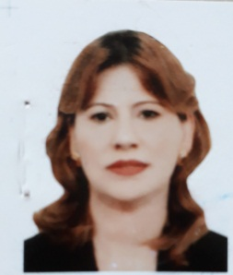
Curriculum Vitae

personal information
Full Name: Karima Fayyad Salem Ahmed Al - Badrani.
Place and date of birth: Baghdad, 8/11/1967.
Nationality: Iraqi.
Marital Status: Married.
Residence: Baghdad.
Title of work: College of Physical Education and Sports Science for Girls / University of Baghdad.
scientific certificates
Bachelor of Sports Education.
Master of Physical Education.
Doctor of Physical Education.
Scientific expertise
1987 - 1992 ....... Instructor of Sports Games, Faculty of Physical Education for girls in shooting, tennis, arena and field.
1996 - 1997 Head of Sports Activity Department, Faculty of Law, University of Baghdad.
1996 - 1997 ... ... Lecture in shooting / Faculty of Physical Education for Girls / University of Baghdad
.
Instructor in the Department of Sports Activity, College of Law.
2014 - 2019 Teaching in the Faculty of Physical Education and Sports Science for Girls
Sports activities and achievements
1987 - 1992 .......... Aerial rifle shooting athlete / Faculty of Physical Education for girls.
Instructor of the Faculty of Physical Education for girls.
1999 - 2000 ............ Shooting Instructor at the Sports Safety Club.
Trainer of the national team of women shooting.
Member of the administrative board of the safety club.
1991 - 2000 ............ Ruler practicing in the effectiveness of shooting.
University Team Trainer (table tennis).
Research
1 - the impact of some teaching methods at the level of technical performance and achievement in the effectiveness of throwing the air gun.
2 - The effect of the training method on the level of technical performance in the effectiveness of shooting with an air gun.
3 - the impact of the use of educational curriculum according to the model Kolb at the level of learning of the effectiveness of shooting with an air gun.
4 - The impact of the strategy of mental maps on the technical performance in the shooting of the air gun.
5. The impact of the use of the method of competitions on the skillful learning of rifle shooting effectiveness.The impact of the PECS strategy on the level of technical performance of the firing of air weapons

